Profile at a glance
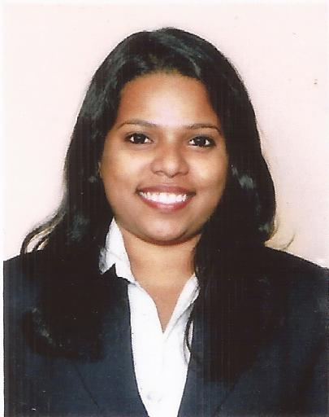
- Result oriented, hardworking, possesses high analytical skills, ability to learn and adapt, good communication and interpersonal skills.
- Key Strengths and areas of interests
  - Performance Appraisal, Competency Mapping, Training & Development.
  - Recruiting/Learning Management & Training System.
  - Administration, Business Development Skills.
Career Objective: Looking forward to work in a progressive organization that offers opportunity to apply, refine and expand knowledge & experience, leading to professional as well as personal growth & satisfaction and to be a major contributor in organization’s progress.

professional Experience
- Currently working with Fernandes Group (Global Recruitment and Staffing Firm), Margao – Goa as a ‘HR Executive’ from November 2013 till Date.
Job Responsibilities:
- Understanding the client requirement, Drafting JD as per the requirements.
- Sourcing candidates from various Job portals such as Naukri & Times Job, & Mass Mailing to create pool of clients.
- Handling recruitment process right from conducting preliminary screening to assigning Job roles including assertion of their competencies, skills & aspirations based on work, position, salary etc.
- Grooming and briefing the candidates for the interview.
- Developing Business by understanding the client requirements and fulfilling it.
- Fabhres.Com : Worked as a ‘Admin Executive’ from June 2013 to November 2013

Summer Internship
ZUARI AGRO CHEMICALS PVT LTD – December 2012 to February 2013 as an Intern.
Company Profile: One of the biggest manufacturing firms of Agro products like Fertilizers, pesticides and micro nutrients.
Department: Human Resources Management.
Objective: To earn exposure and garner knowledge in the area of Human Resource Management and to improve the HR activities by implementation of Dashboard.

SUMMER PROJECT :Live Project: Research project on “Extraction and Partial Purification of Pharmaceutically Important Enzyme- Cholesterol Oxidase from a Novel Microbial Isolate”. Published the same in an online journal, “International Journal of Applied Biology & Pharmaceutical Technology” Vol. 2, Issue 2, (April-June 2011) (Ref.: www.ijabpt.com)
Extra Curricular Activities
- Awarded 2nd place in HR event at IMER management event(2013)
- Have been an active member in organizing team of annual event Advaith’12 (Gogte Institute of Technology [MBA])
- Awarded “Best Dream Team Member” as a member of the college (Gogte Institute of Technology [MBA]) students’ newsletter ‘Word’s Worth’.
- Presented a paper at National Symposium on Microbial Diversity and its Applications in Health, Agriculture and Industry held in, 2011 at ICAR Research Complex for Goa.
- Presented a paper in National Seminar on Frontiers in Biotechnology held at Changu Kana Thakur Arts, Commerce and Science College New Panvel Maharashtra Between December 3-4, 2010.
- Awarded 2nd place in Botany & 3rd place in Biotechnology seminar presentation competition.
Technical Skills
Diploma in Computer Applications
- E-Office: - MS-Word, MS-Excel, Power Point, Internet.
- E- Finance: - Tally 9.0 VAT Enabled
- Basic of IT, Fundamental of E-commerce, MS Access, MS Front page, Corel Draw X3
Education Qualifications
- First Class - MBA (Human Resource Management) from VTU University in 2013 with 68%
- First Class - B.Sc. Biotechnology from Goa University in 2011 with 65%
- Second Class - HSC from Goa State Board in 2008 with 50%
- First Class - SSC from Goa State Board in 2006 with 65 %
Personal details
- Date of Birth: 20th September 1990.
- Marital Status: Unmarried.
- Hobby: Learning dance, Singing Socializing people, watching movies, etc.
- Languages known: English, Hindi, Marathi & Konkani.
- Reference: Available on request . Ms. Prachi P. Gawde

